Automated Vernacular Fact-Checking System – Architecture & Plan
1. High-level system architecture & pipeline stages
Ingestion LayerPreprocessing & NormalizationFact Retrieval & VerificationAPI & UISocialFeedIngestorNewsRSSIngestorWebScraperkafka_topic_raw_postsLangDetectorNormalizer & CleanerFluffIrrelevantFilterClaimExtractorkafka_topic_claimsHybridRetrieverFactDB + VectorStoreClaimVerifierConfidenceScorerkafka_topic_resultsBackendAPI(FastAPI)ReviewerDashboard
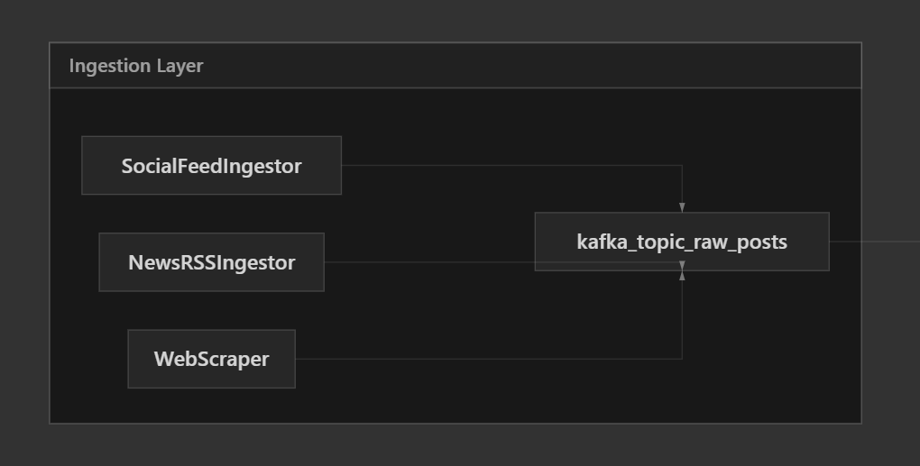
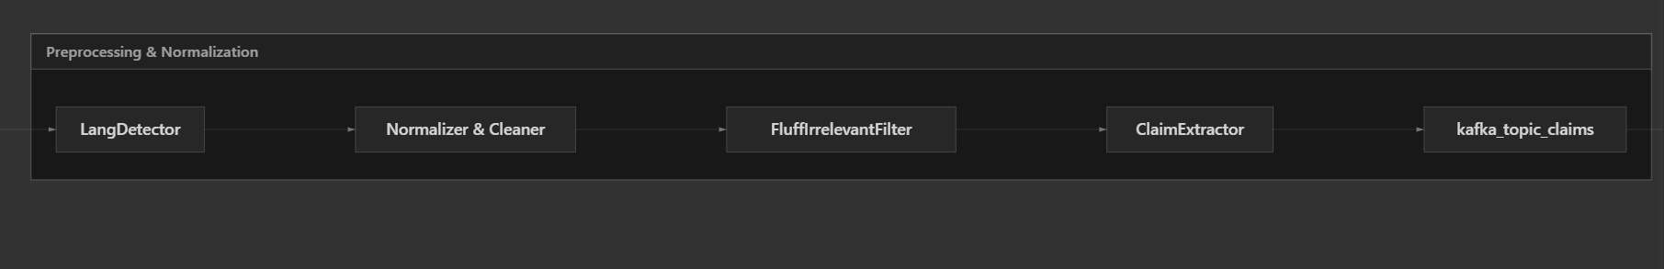
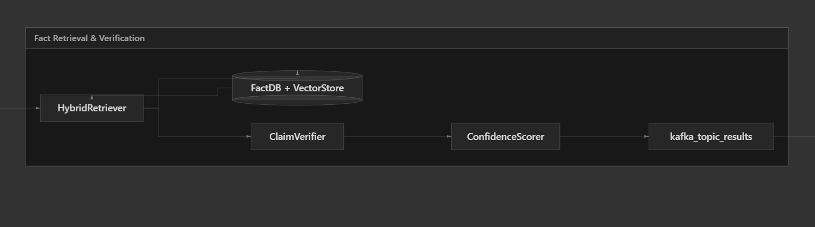
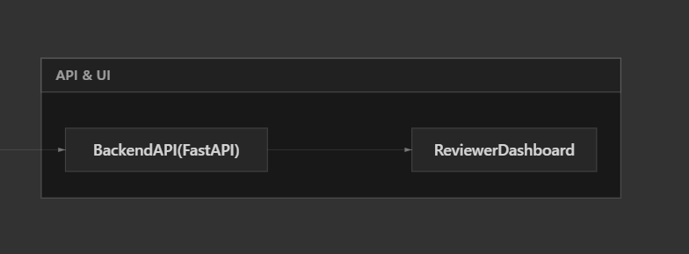
flowchart LR
subgraph ingestLayer [Ingestion Layer]
socialAPIs[SocialFeedIngestor]
rssIngest[NewsRSSIngestor]
webScraper[WebScraper]
queueIn[kafka_topic_raw_posts]
end

subgraph preprocessingLayer [Preprocessing & Normalization]
langDetect[LangDetector]
normalizeText[Normalizer & Cleaner]
fluffFilter[FluffIrrelevantFilter]
claimExtractor[ClaimExtractor]
queueClaims[kafka_topic_claims]
end

subgraph factCheckLayer [Fact Retrieval & Verification]
retriever[HybridRetriever]
factDB[(FactDB + VectorStore)]
verifier[ClaimVerifier]
scorer[ConfidenceScorer]
queueResults[kafka_topic_results]
end

subgraph apiLayer [API & UI]
backendAPI[BackendAPI(FastAPI)]
reviewerUI[ReviewerDashboard]
end

socialAPIs --> queueIn
rssIngest --> queueIn
webScraper --> queueIn

queueIn --> langDetect --> normalizeText --> fluffFilter --> claimExtractor --> queueClaims
queueClaims --> retriever
retriever --> factDB
factDB --> retriever
retriever --> verifier --> scorer --> queueResults

queueResults --> backendAPI --> reviewerUI
1.1 Stages
- Ingestion layer
  - Connectors to Twitter/X, Facebook, Instagram, YouTube comments, WhatsApp-like proxies (if any), and news sites (RSS, sitemaps, HTML scrapers).
  - Write normalized RawPost records into kafka_topic_raw_posts (or similar message queue) with metadata (source, language hint, timestamp, geo, engagement, author).
- Preprocessing & claim extraction layer
  - Language detection & transliteration: detect language + script (e.g., Hindi in Devanagari vs Latin), transliterate to canonical script for some models.
  - Normalization & cleaning: remove URLs, emojis (optional), HTML, excessive punctuation; normalize Unicode; standardize hashtags/usernames.
  - Fluff & irrelevant text filtering: remove greetings, sign-offs, discourse markers, and non-claim chatter; score sentences for claim-likeness.
  - Claim segmentation & extraction: split text into sentences/clauses; identify and extract check-worthy factual claims.
  - Output: Claim records (claim text, language, source_post_id, entities, time, geo, topic) to kafka_topic_claims.
- Fact retrieval & verification layer
  - Hybrid retrieval from fact DB: BM25 + dense embeddings (vector search) + optional keyword filters.
  - Context construction: build a context bundle of top-k candidate facts + evidence, normalized entities, and metadata (time, place).
  - Verification: ML or rule-based labeler decides {Supported, Refuted, NotEnoughEvidence, NeedsReview} and assigns confidence.
  - Misinformation detection: flag posts/claims that are refuted or unknown but potentially dangerous (e.g., health/election-related, viral).
  - Output: FactCheckResult records to kafka_topic_results and persisted in DB.
- API & presentation layer
  - Backend API (FastAPI) to:
    - Query fact-check results by post URL, ID, or text.
    - Provide search UI for fact-checkers.
    - Expose admin tools to manage fact DB.
  - Frontend dashboard (React) for:
    - Monitoring live stream of claims and statuses.
    - Manual review/override of low-confidence cases.
    - Annotation interface for building the verified fact database.
- Storage & infrastructure
  - Operational store: PostgreSQL (claims, posts, results, users, annotations, jobs).
  - Search: Elasticsearch/OpenSearch for keyword + filters.
  - Vector store: FAISS / Milvus for dense embeddings of claims/facts.
  - Object storage: MinIO/S3 for raw HTML, screenshots, training data dumps.
  - Orchestration/Deployment: Docker + Kubernetes (or docker-compose for student scope), Prometheus/Grafana for metrics.

2. Methods for high-throughput processing (thousands of posts/min)
- Message queues for decoupling
  - Kafka or Redpanda topics per stage: raw_posts, normalized_posts, claims, results.
  - Consumers scaled horizontally; partitions align with throughput needs.
- Horizontal scaling of stateless workers
  - Microservices or modular workers:
    - ingest-service, preprocess-service, claim-extractor-service, retriever-service, verifier-service.
  - Each runs multiple replicas behind a queue; scale out by running more replicas.
- Batch & micro-batch processing
  - Process messages in small batches (e.g., 16–128 posts) to exploit vectorization in NLP models (PyTorch batch inference).
  - Group by language to reduce model switching overhead.
- Asynchronous I/O and concurrency
  - Use async FastAPI for APIs.
  - Workers use async HTTP clients for external APIs, non-blocking DB drivers where possible.
- Caching
  - Redis cache for:
    - Popular posts and their results.
    - Recently computed embeddings of common text fragments (e.g., viral messages forwarded multiple times).
    - Frequently used fact entries and retrieval results.
- Backpressure & prioritization
  - Kafka consumer groups with max poll interval + lag monitoring.
  - Prioritize high-impact sources (e.g., verified political accounts, highly shared URLs) using priority queues or separate topics.
- Observability
  - Metrics: per-stage throughput, latency histograms, error rates, queue lag, GPU utilization.
  - Logs: structured JSON logs for each worker; correlation IDs for tracing per post/claim.

3. Techniques to maintain context accuracy in the fact database
- Fact schema design
  - Fact entity fields:
    - id, canonical_claim_text, language, translations.
    - entities (linked to entity store), time_validity (from/to), geo_scope (country/state/city).
    - source (fact-checking org, article URL, evidence URLs), verdict (True/False/Misleading/etc.).
    - topic_tags (health, politics, crime, finance, religion, etc.).
- Entity-centric modeling
  - Separate Entity table (persons, orgs, places, events) with aliases across languages and scripts.
  - Use NER + entity linker to map claims to entities; retrieval is then entity-aware.
- Time & geography-aware retrieval
  - Include time and geo filters in retrieval queries.
  - Example: claim about “fuel price now” should prioritize recent facts from the same country/state.
- Hybrid retrieval for context accuracy
  - BM25 (Elasticsearch) on normalized text, plus filters on language, topic, time.
  - Dense retrieval (FAISS/Milvus) using multilingual encoders (e.g., XLM-R, IndicBERT) for semantic similarity across languages.
  - Re-ranking with cross-encoder models that take [claim, fact] pairs and output relevance scores.
- Normalization & canonicalization pipeline for new facts
  - When ingesting new verified facts:
    - Normalize text (same preprocessing as incoming claims).
    - Extract entities, time, location, topics.
    - Generate embeddings for canonical claim and translations.
    - Store full provenance (links to sources, authors, publication date).
- Human-in-the-loop review
  - UI to approve/edit canonical claims, correct entities, and mark duplicates.
  - Periodic deduplication job to merge semantically identical facts across languages.
- Versioning & auditability
  - Maintain version history for each fact.
  - Store which model version produced which verdict for reproducibility.

4. NLP methods to remove conversational fluff and irrelevant text
- Rule-based preprocessing
  - Regex and heuristics to strip:
    - Greetings ("good morning", "namaste", "salaam", equivalents in Indian languages).
    - Courtesy phrases ("please share", "forward this", "subscribe", "like/comment/share").
    - User mentions, hashtags (optionally keep content words from hashtags), emojis, excessive punctuation.
- Sentence segmentation and classification
  - Split text into sentences/clauses using language-specific sentence boundary detection (Indic NLP library, spaCy models, or rule-based for resource-poor languages).
  - Train a binary classifier (claim vs non-claim) on sentences:
    - Models: small transformers (e.g., xlm-roberta-base, indic-bert) fine-tuned for claim detection.
    - Negative examples: jokes, opinions, questions without factual assertions, chit-chat.
- Claim-worthiness scoring
  - Multi-class classifier to rank sentences by check-worthiness (e.g., elections, public health, communal issues).
  - Use thresholds to drop low-scoring sentences.
- Dependency & POS-based heuristics
  - Use syntactic patterns to ensure factual assertions (presence of verbs, entities, numbers, dates).
  - Filter out isolated nouns or fragments (e.g., just a URL or hashtag cloud).
- Summarization for long posts
  - For long rants or threads, use extractive summarization based on claim-worthiness scores to reduce to a few key factual sentences before retrieval.
- Template & keyword filters
  - Maintain lists of generic phrases (e.g., "like and share", "I think", "in my opinion") in multiple languages to downweight/remove those segments.

5. Strategies for multilingual processing for Indian languages
- Language & script detection
  - Use fast language ID (fastText langid models) trained/fine-tuned for Indian languages.
  - Detect script (Devanagari, Latin, Bengali, Gurmukhi, etc.) via Unicode ranges.
- Transliteration & normalization
  - For code-mixed and Romanized Indian languages, use transliteration libraries or sequence models to map to native scripts (e.g., Hindi Latin → Devanagari).
  - Normalize spacing, digits (Devanagari numerals → ASCII), dates, and currency formats.
- Shared multilingual encoders
  - Use models like IndicBERT, MuRIL, XLM-R so that semantically similar claims in different languages are mapped to nearby vector space locations.
  - Fine-tune for retrieval and classification tasks (claim detection, stance classification) with multilingual datasets.
- Language-specific components where needed
  - Per-language stopword lists, punctuation rules, and slang dictionaries.
  - Optional per-language light stemmers or lemmatizers.
- Code-mixing handling
  - Identify mixed-language stretches at the token level; route to models fine-tuned on code-mixed data.
  - Use token-level language tags to help models disambiguate.
- Multilingual fact DB
  - Store canonical fact in primary language plus translations.
  - For retrieval, search across all languages using embeddings; but apply language preferences (e.g., prefer same-language evidence first, then cross-lingual).
- Evaluation per language
  - Track precision/recall by language and key dialect groups to avoid underperformance on low-resource languages.

6. Recommended tools, frameworks, and ML models
- Programming & frameworks
  - Python 3.11+ as main language.
  - FastAPI for backend APIs.
  - Kafka/Redpanda for streaming; alternatively RabbitMQ for smaller-scale student deployments.
  - Celery + Redis or Kafka consumer workers for background processing.
  - PostgreSQL for relational data.
  - Elasticsearch/OpenSearch for full-text + BM25 retrieval.
  - FAISS or Milvus for vector similarity search.
- NLP & ML
  - PyTorch / HuggingFace Transformers for model training/inference.
  - spaCy for tokenization, NER (where models exist), custom pipelines; integrate with Indic NLP tools.
  - Indic NLP Library and similar projects for tokenization, transliteration, and script handling for Indian languages.
- Candidate models (for student-friendly setup)
  - Language-agnostic sentence embeddings: sentence-transformers/paraphrase-multilingual-mpnet-base-v2.
  - Indic-focused: ai4bharat/indic-bert, google/muril-base-cased, xlm-roberta-base fine-tuned.
  - Claim detection / stance classification: fine-tune above encoders on claim datasets (e.g., FakeNewsNet, ClaimBuster-like sources, Indian fact-check corpora where available).
- Frontend
  - React + TypeScript with Vite or Next.js.
  - UI: Tailwind CSS or Material UI.
  - Charts/metrics: Recharts, Chart.js, or ECharts.
- DevOps & tooling
  - Docker for containerization; docker-compose for local.
  - GitHub Actions or GitLab CI for CI/CD.
  - Poetry or pip + requirements.txt for Python deps.

7. Example project folder structure
- Root
  - backend/
    - app/
      - main.py (FastAPI entrypoint)
      - api/
        - routes_posts.py
        - routes_claims.py
        - routes_facts.py
        - routes_admin.py
      - core/
        - config.py
        - logging.py
      - models/
        - post.py
        - claim.py
        - fact.py
        - fact_check_result.py
        - user.py
      - db/
        - session.py
        - schemas.sql or Alembic migrations
      - services/
        - ingest_service.py
        - preprocess_service.py
        - claim_extractor_service.py
        - retrieval_service.py
        - verification_service.py
        - cache_service.py
      - workers/
        - kafka_consumer_claims.py
        - kafka_consumer_results.py
      - tests/
    - Dockerfile
    - requirements.txt
  - ml/
    - notebooks/
    - data/ (small samples; big data in external storage)
    - models/
      - claim_detector/
      - stance_classifier/
      - retriever_encoder/
    - training/
      - train_claim_detector.py
      - train_stance_classifier.py
    - inference/
      - claim_detector.py
      - fluff_filter.py
      - embedder.py
      - retrieval_pipeline.py
  - frontend/
    - src/
      - App.tsx
      - components/
        - LiveFeed.tsx
        - ClaimCard.tsx
        - FactCheckDetail.tsx
        - FiltersPanel.tsx
        - AnnotationForm.tsx
      - pages/
        - Dashboard.tsx
        - ClaimReview.tsx
        - FactDatabase.tsx
      - services/
        - api.ts (REST client)
    - public/
    - package.json
  - infra/
    - docker-compose.yml
    - k8s/ (optional manifests)
  - docs/
    - architecture.md
    - api-spec.md
    - ml-design.md
  - README.md

8. Team structure and work division
8.1 Member A – Backend Engineer
- Responsibilities
  - Design and implement the backend services, REST APIs, and message-driven workers.
  - Integrate with Kafka/Redis, PostgreSQL, Elasticsearch, FAISS/Milvus (through ML engineer’s modules).
  - Implement authentication/authorization for internal dashboard.
  - Expose endpoints for ingestion, fact-check results, fact DB management, and annotations.
  - Implement monitoring, logging, and basic rate limiting.
- Key technologies
  - Python, FastAPI, Pydantic.
  - Kafka (or Redis Streams/RabbitMQ for simpler setup).
  - PostgreSQL, SQLAlchemy/SQLModel.
  - Elasticsearch/OpenSearch client.
  - Redis for caching.
  - Docker, docker-compose.
- Step-by-step tasks
  - Core backend scaffold
    - Initialize backend/ FastAPI project with environment-based config.
    - Set up DB connection (PostgreSQL) and ORM models for posts, claims, facts, results, users.
  - API design & implementation
    - Implement GET /health, GET /stats for monitoring.
    - Implement APIs:
      - POST /ingest/post (for testing/manual input).
      - GET /posts/{id} and GET /claims/{id}.
      - GET /fact-check with query by text or URL.
      - Admin endpoints for CRUD on facts and users.
  - Messaging and workers
    - Implement Kafka consumer/producer wrappers.
    - Build workers to:
      - Read from raw_posts and call ML preprocessing/claim extraction (via ML modules).
      - Read claims from claims and call retrieval/verification ML modules.
      - Save results to DB and publish to results topic.
  - Caching and performance
    - Integrate Redis caching for hot results and metadata.
    - Add simple request-level caching for the most common queries.
  - Security & auth
    - Implement JWT-based auth for internal dashboard APIs.
  - Monitoring & logging
    - Add structured logging middleware.
    - Add Prometheus metrics endpoints if time allows.
- Files/modules Member A will create
  - backend/app/main.py
  - backend/app/core/config.py, logging.py
  - backend/app/models/{post,claim,fact,fact_check_result,user}.py
  - backend/app/api/{routes_posts,routes_claims,routes_facts,routes_admin}.py
  - backend/app/services/{ingest_service,preprocess_service,claim_extractor_service,retrieval_service,verification_service,cache_service}.py
  - backend/app/workers/{kafka_consumer_claims,kafka_consumer_results}.py
  - backend/requirements.txt
- Expected outputs
  - Running backend service exposing REST APIs and Kafka workers.
  - Database schema for posts/claims/facts/results.
  - Internal documentation in docs/api-spec.md describing endpoints.
- Integration with others
  - Consumes ML modules from Member C as Python packages/modules (ml/inference/*).
  - Provides HTTP APIs for Member B’s frontend and annotation UI.
  - Exposes admin endpoints to let Member C update fact DB and trigger re-indexing.

8.2 Member B – Frontend Engineer
- Responsibilities
  - Build the web dashboard for monitoring streams, reviewing claims, and managing facts.
  - Implement UI components for browsing posts, viewing fact-check results, and annotating new facts.
  - Provide clear UX for multilingual content and filtering.
  - Integrate with backend APIs for live updates (polling or websockets if added later).
- Key technologies
  - React + TypeScript.
  - Tailwind CSS or Material UI.
  - Axios or Fetch for API calls.
  - Vite/Next.js for build/dev environment.
- Step-by-step tasks
  - Project setup
    - Initialize React + TypeScript project in frontend/.
    - Configure routing (e.g., React Router).
  - Design system & layout
    - Create core layout: navbar, sidebar, main content area.
    - Define color palette and typography suitable for data-heavy dashboards.
  - Dashboard views
    - Dashboard page:
      - Live table/stream of latest claims with status, language, source.
      - Filters by language, verdict, confidence, topic.
    - ClaimReview page:
      - Detail view showing original post text, extracted claims, evidence facts, model verdict, and confidence.
      - Controls to approve/override, assign labels for training data.
    - FactDatabase page:
      - Search and browse verified facts.
      - Form to add/edit facts (including language, entities, time/geo scope).
  - API integration
    - Implement frontend/src/services/api.ts to talk to backend endpoints (Member A).
    - Map responses to TypeScript types.
  - User auth UI
    - Basic login form, token storage, and logout.
  - UX enhancements & validation
    - Loading states, error handling, pagination.
    - Indicate model confidence visually (e.g., colored badges).
- Files/modules Member B will create
  - frontend/src/App.tsx
  - frontend/src/pages/{Dashboard,ClaimReview,FactDatabase}.tsx
  - frontend/src/components/{LiveFeed,ClaimCard,FactCheckDetail,FiltersPanel,AnnotationForm,Navbar,Sidebar}.tsx
  - frontend/src/services/api.ts
  - frontend/package.json, config files.
- Expected outputs
  - Working single-page dashboard that interacts with backend APIs.
  - Annotation interface for fact-checkers to label claims and add facts.
  - Basic styling and responsive layout.
- Integration with others
  - Uses backend REST APIs from Member A for data.
  - Sends annotation data (labeled claims, new facts) that Member C can use to improve models.
  - Displays language, confidence, and model outputs provided by Member C’s modules via backend.

8.3 Member C – ML/Data Engineer
- Responsibilities
  - Design and implement all NLP/ML components: preprocessing, language detection, fluff removal, claim extraction, retrieval, and verification.
  - Build and maintain the fact database’s indexing (text + vector) pipelines.
  - Prepare datasets, train/fine-tune models, and ship inference modules consumable by backend.
- Key technologies
  - Python, Jupyter notebooks.
  - PyTorch, HuggingFace Transformers.
  - spaCy, Indic NLP Library.
  - FAISS or Milvus for vector search.
  - Pandas, scikit-learn for data prep and basic baselines.
- Step-by-step tasks
  - Data collection & preprocessing
    - Collect sample datasets from public Indian fact-checking sites and open datasets.
    - Build scripts to parse, clean, and normalize text (multi-language support).
  - Language/script detection module
    - Train/finetune or adopt existing lang ID model for Indic languages.
    - Implement detect_language(text) and detect_script(text) functions.
  - Fluff filtering & claim detection
    - Implement heuristic cleaner (remove URLs, emojis, boilerplate phrases in multiple languages).
    - Create labeled dataset for claim vs non-claim at sentence level.
    - Fine-tune a small multilingual transformer as claim detector; export inference code.
  - Claim extraction pipeline
    - Combine sentence splitter + claim detector to output structured Claim objects.
  - Retrieval pipeline
    - Choose embedding model (e.g., XLM-R or IndicBERT-based sentence transformer).
    - Build scripts to index verified facts into FAISS/Milvus + Elasticsearch.
    - Implement hybrid retrieval: BM25 + vector similarity + re-ranking.
  - Verification / stance classification
    - Train model to classify [claim, fact] pairs as Supported / Refuted / NotEnoughEvidence.
    - Implement scoring and threshold tuning.
  - Packaging & integration
    - Wrap all inference code into lightweight modules callable from backend:
      - ml/inference/claim_detector.py
      - ml/inference/fluff_filter.py
      - ml/inference/embedder.py
      - ml/inference/retrieval_pipeline.py
      - ml/inference/verifier.py
    - Provide clear function signatures and configuration options.
  - Evaluation & monitoring
    - Define evaluation metrics per language (precision/recall/F1 for claim detection, retrieval quality, stance classification).
    - Provide evaluation scripts and reports.
- Files/modules Member C will create
  - ml/notebooks/*.ipynb for experiments.
  - ml/data_preparation/*.py for scraping and preprocessing.
  - ml/training/{train_claim_detector.py,train_stance_classifier.py}.
  - ml/inference/{claim_detector.py,fluff_filter.py,embedder.py,retrieval_pipeline.py,verifier.py}.
  - ml/models/ storing checkpoints (small for repo, larger in external storage).
  - docs/ml-design.md documenting model choices and pipelines.
- Expected outputs
  - Trained or fine-tuned models (or configured open models) for:
    - Language detection (or integrated third-party model).
    - Claim detection and claim-worthiness.
    - Retrieval embeddings and hybrid retrieval.
    - Stance classification / verification.
  - Reusable Python modules for inference, ready to be imported by backend services.
- Integration with others
  - Provides Python inference APIs and config files to Member A for integration in workers.
  - Supplies evaluation metrics and guidelines so Member B can surface model performance in the UI.
  - Consumes annotation data (labels, new facts) from frontend/ backend to retrain/refine models.

9. Suggested initial milestones (for the team)
- Milestone 1 – Skeleton system (Week 1–2)
  - Backend: health APIs, DB schema, minimal ingest + result endpoints.
  - Frontend: static dashboard mock with dummy data.
  - ML: basic preprocessing, off-the-shelf multilingual embeddings, trivial keyword-based retrieval.
- Milestone 2 – End-to-end MVP (Week 3–4)
  - Claim extraction and simple verification in one or two languages (e.g., Hindi + English).
  - Kafka-based pipeline wired up with at least one ingestion source.
  - Dashboard shows live claims and verdicts.
- Milestone 3 – Multilingual & optimization (Week 5–6)
  - Add more Indian languages and better claim detection.
  - Implement fluff removal, hybrid retrieval, and time/geo-aware filters.
  - Improve UI for annotation and incorporate feedback loop into ML training.

